**Task 3: Writing Basic SELECT Queries**

* **Objective:** Extract data from one or more tables.

1. **Use SELECT * and specific columns**
2. **Apply WHERE, AND, OR, LIKE, BETWEEN**
3. **Sort with ORDER BY**

**Working on Employee table:**

**i)**

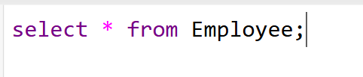

**Output:**

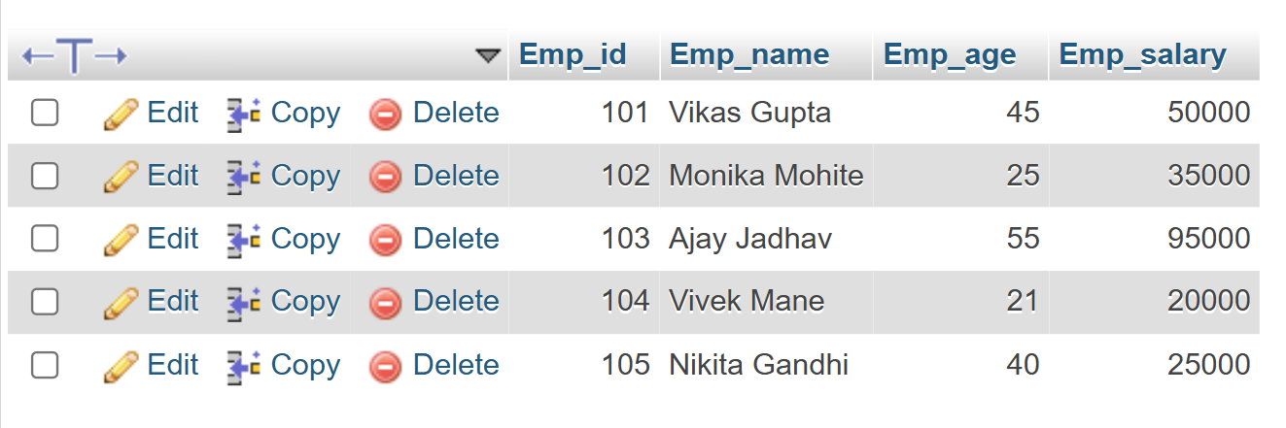

**ii) 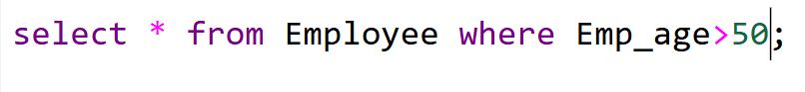  
  
Output:** 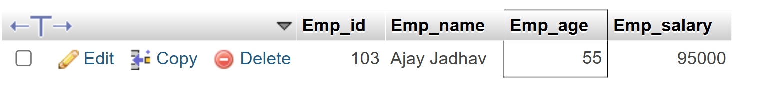

**iii)** 

**Output:** 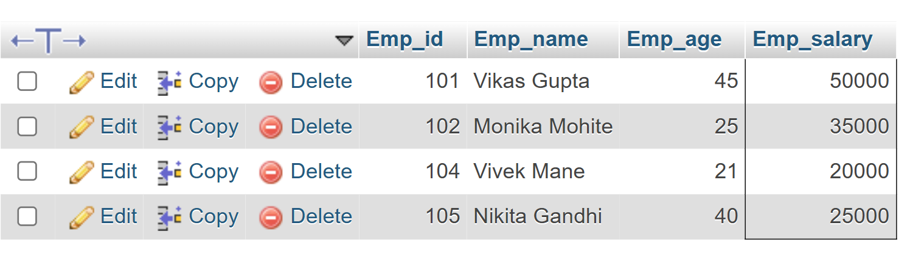

**iv)** 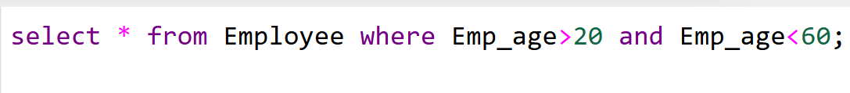

**Output:** 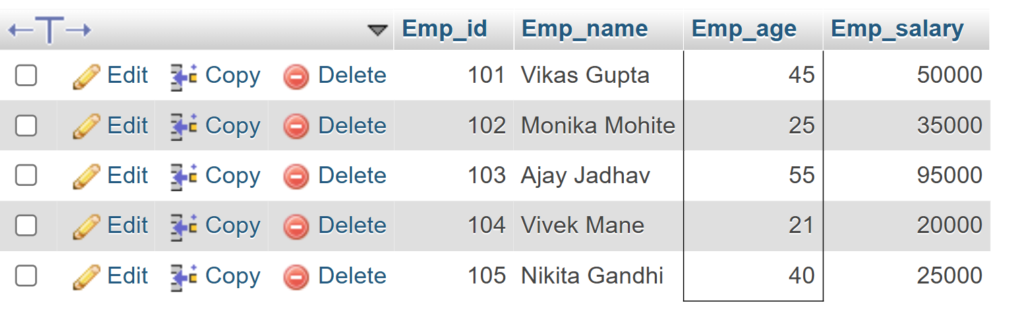

**v)** 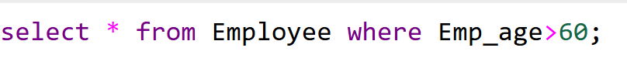

**Output:**

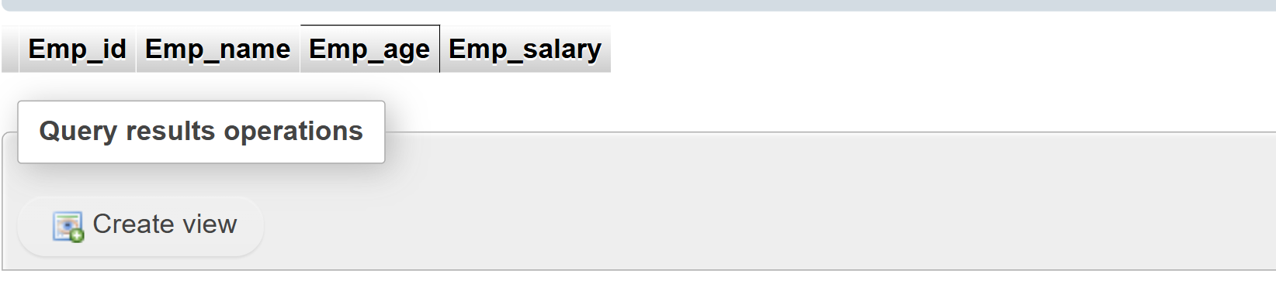

**vi)** 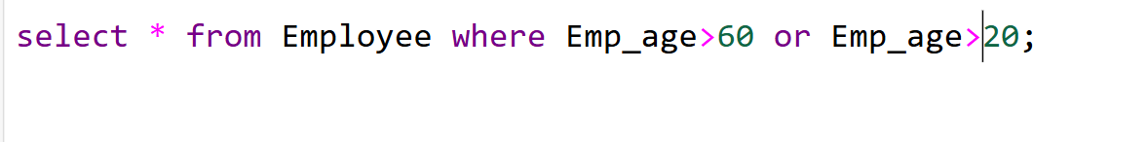

**Output:**

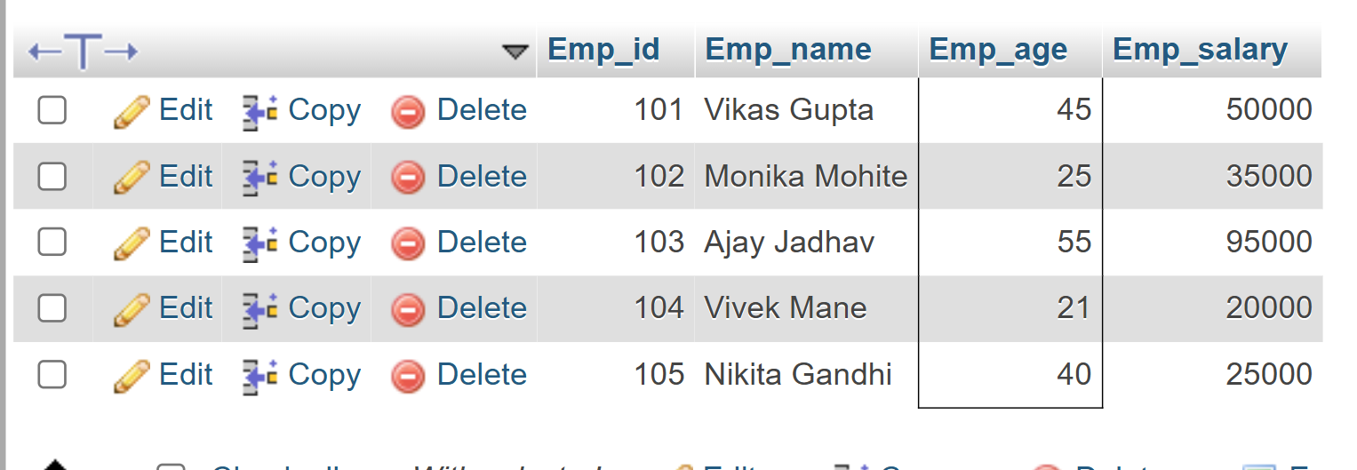

**vi)** 

**Output:** 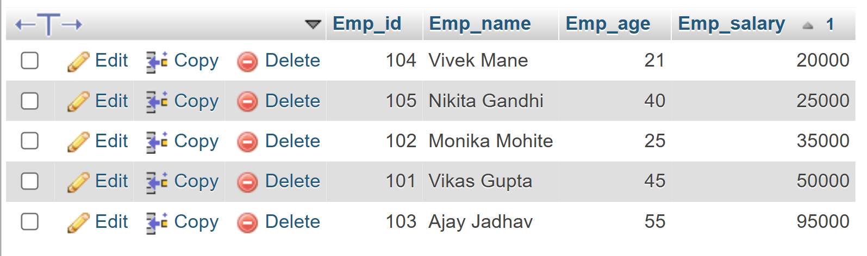

**vii)** 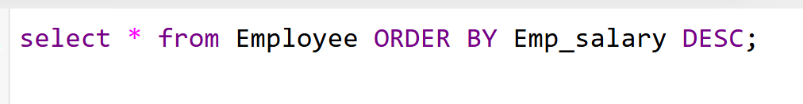

**Output:** 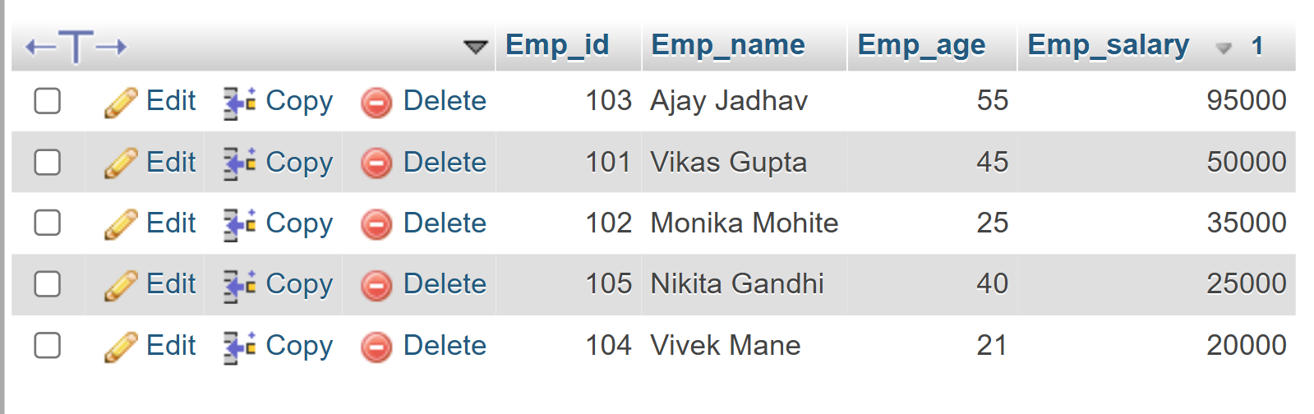

**viii)** 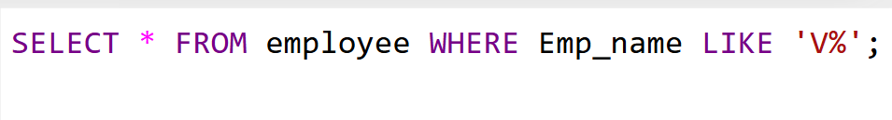

**Output:**

